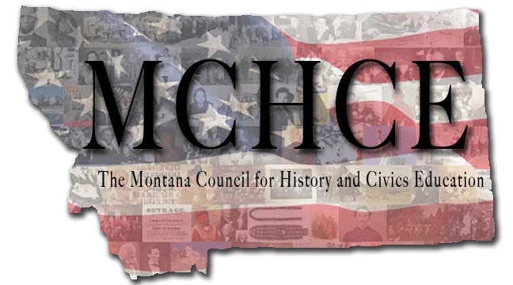

Project Topics, Dates, Places, and Timeline

Year One: 2010-2011
- Fall Colloquium: Revolution and Early Republic (1770-1787)
October 21-22, 2010, Helena, MT

- Winter Colloquium: The New Nation, Part 1 (1785-1830)
January 25-27, 2011, Bozeman, MT

- Summer Institute: The New Nation, Part 2 (1785-1850)
June 14-17, 2011, Bozeman, MT

Year Two: 2011-2012
- Fall Colloquium: Expansion and Reform (1800-1860)
During MEA days in October 2011, Great Falls, MT

- Winter Colloquium: The Civil War and Reconstruction (1850-1880)
January, 2012, Helena, MT

- Summer Institute: The Greater Reconstruction (1865-1893)
June, 2012, Helena, MT

Year Three: 2012-2013
- Fall Colloquium: America Becomes a Modern Society (1880-1915)
During MEA days in October 2012, Bozeman, MT

- Winter Colloquium: Crisis and Conflict (1915-1945)
January 2013, Great Falls, MT

- Summer Institute: Montana, the United States, and the World in the 20th Century (1890-Present)
June 2013, Great Falls, MT

